# **Name: Abdurrahman Qureshi**

# **Roll No: 210451**

Practical No: 5

1) Convert U.S. Dollars to Indian Rupees.

Code:

usd = float(input("Enter your amount in USD: "))  
inr = usd * 83.12  
print(usd, " USD => ", inr, " INR")

Output:

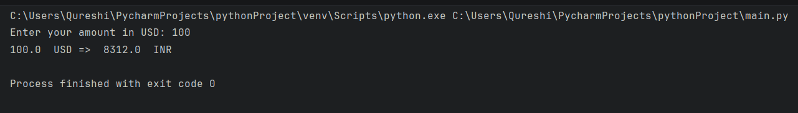

2) Convert bits to Megabytes, Gigabytes and Terabytes.

Code:

bits = float(input("Enter the number of bits: "))  
byte = bits / 8  
kiloBytes = byte / 1024  
megaBytes = kiloBytes / 1024  
gigaBytes = megaBytes / 1024  
teraBytes = gigaBytes / 1024  
print(bits, " bits in Megabytes: ", megaBytes)  
print(bits, " bits in Gigabytes: ", gigaBytes)  
print(bits, " bits in Terabytes: ", teraBytes)

Output:

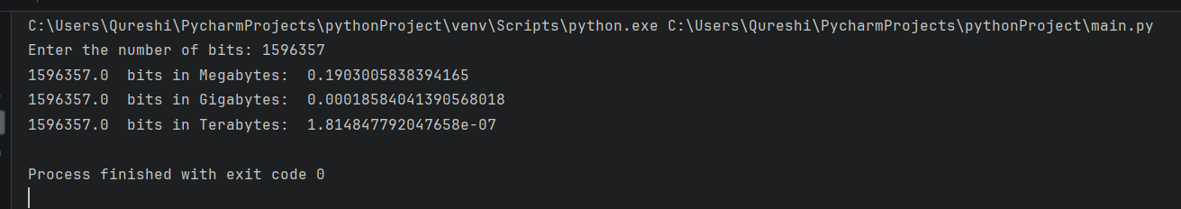

3) Find square root of a number.

Code:

inputNum = float(input("Enter a number: "))  
print("The square root of ", inputNum, " is ", inputNum ** 0.5)

Output:

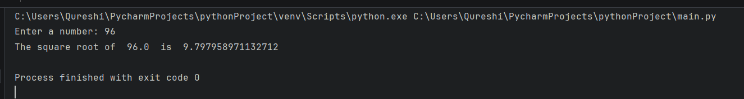

4) Find area of a rectangle.

Code:

length = float(input("Enter the length of a rectangle: "))  
breadth = float(input("Enter the breadth of a rectangle: "))  
area = length * breadth  
print("The area of the rectangle is: ", area, "square units.")

Output:

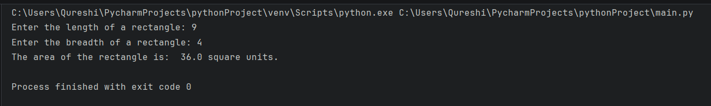

5) Calculate area and perimeter of a square.

Code:

side = float(input("Enter the length of the side of a square: "))  
perimeter = 4 * side  
area = side * side  
print("The area of the square is: ", area, "square units.")  
print("The perimeter of the square is: ", perimeter, "square units.")

Output:

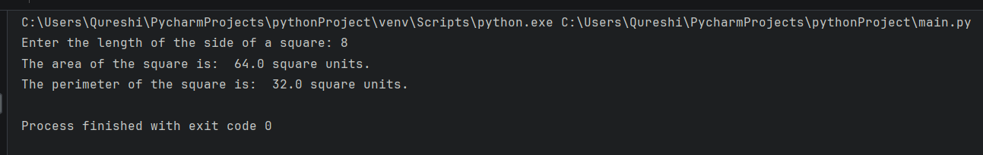

6) Surface area and volume of a cylinder.

Code:

radius = float(input("Enter the radius of a cylinder: "))  
height = float(input("Enter the height of a cylinder: "))  
surfaceArea = 2 * 3.14 * radius * height + 2 * 3.14 * radius * radius  
volume = 3.14 * radius * radius * height  
print("The surface area of the cylinder is: ", surfaceArea, "square units.")  
print("The volume of the cylinder is: ", volume, "square units.")

Output:

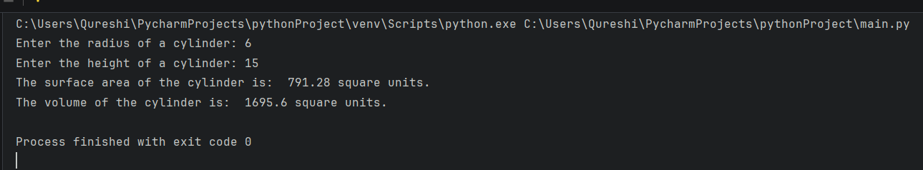

7) Swap the value of two variables.

Code:

a = int(input("Enter a number: "))  
b = int(input("Enter another number: "))  
print("Before swap: a = ", a, ", b = ", b)  
temp = a  
a = b   
b = temp  
print("After swap: a = ", a, ", b = ", b)

Output:

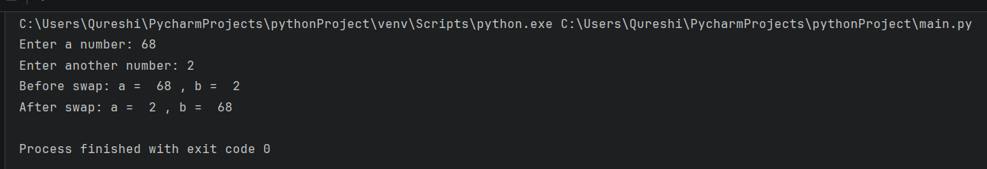

8) Solve quadratic equations.

Code:

a = float(input("Enter the coefficient a: "))  
b = float(input("Enter the coefficient b: "))  
c = float(input("Enter the coefficient c: "))  
print("Generated quadratic equation:\n", a, "x^2 + ", b, "x + ", c, " = 0")  
discriminant = b ** 2 - 4 * a * c  
if discriminant >= 0:  
 root_1 = (-b + discriminant ** 0.5) / (2 * a)  
 root_2 = (-b - discriminant ** 0.5) / (2 * a)  
 print("Roots of the quadratic equation are:\nRoot 1: ", root_1, "Root 2: ", root_2)  
else:  
 print("The roots of this quadratic equation are not real. BRUH?")

Output:

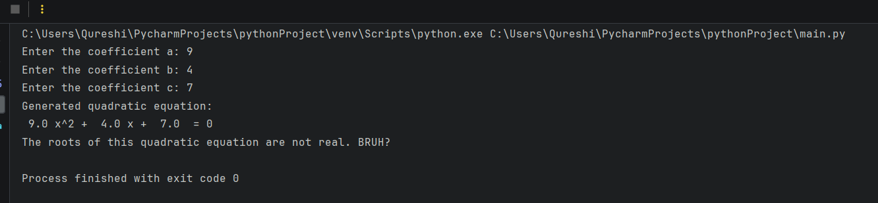

8) Print current date and time.

Code:

import datetime

currentTime = datetime.datetime.now()

print(currentTime.strftime("%Y-%m-%d %H:%M:%S"))

Output:

